## Setting up VBox Share

### Debian

There is a method available for uploading files to our VirtualBox instance of Debian VM. It involves using the VirtualBox shared folder for that machine. Before you begin, you need to setup Debian to allow this. It involves installing extra software, as below. Login as root, or login regularly and become root, and install:

apt -y install build-essential module-assistant linux-headers-amd64 linux-headers-4.9.0-8-amd64

This allows you to use the VirtualBox guest software with Debian. We can now install the guest software. We do this by a virtual CDROM available within VirtualBox. If the menu is not available, try Right Ctrl + C or Right Ctrl + F to get out of Scaled mode or Full Screen.

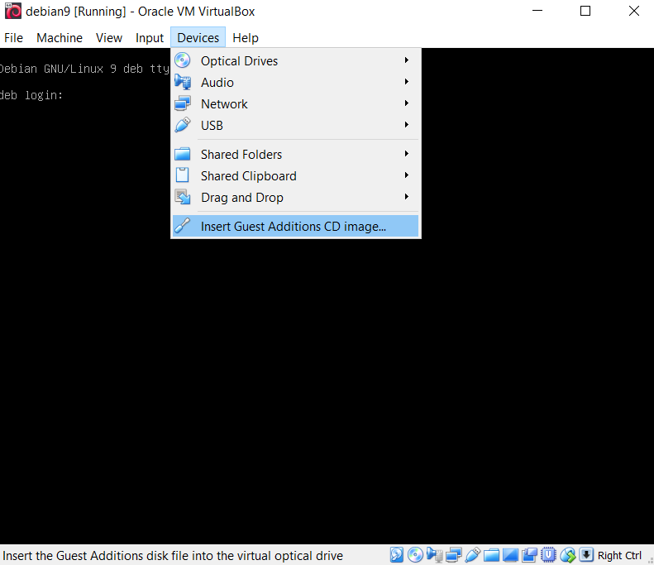

Once inserted, you need to mount this CD. This is done with the following:

mount /dev/cdrom /media/cdrom

Once mounted, you can navigate to that directory and run the installer:

cd /media/cdrom

./VBoxLinuxAdditions.run

This will install the necessary files to set up a shared folder between your host and virtual machines. Again, run as root.

Now we can set up the share. It is recommended you restart your VM at this point, but we will merely shut it down for now. Using right Ctrl + H key to shut Debian down.

Go to the settings of your VM, and modify your Shared Folders, click on the + folder to add a new share, and give it a share name. Attach it to a share in your host environment (below, I created a folder in my Documents folder called debian_share). I then called that new shared folder debian_share again.

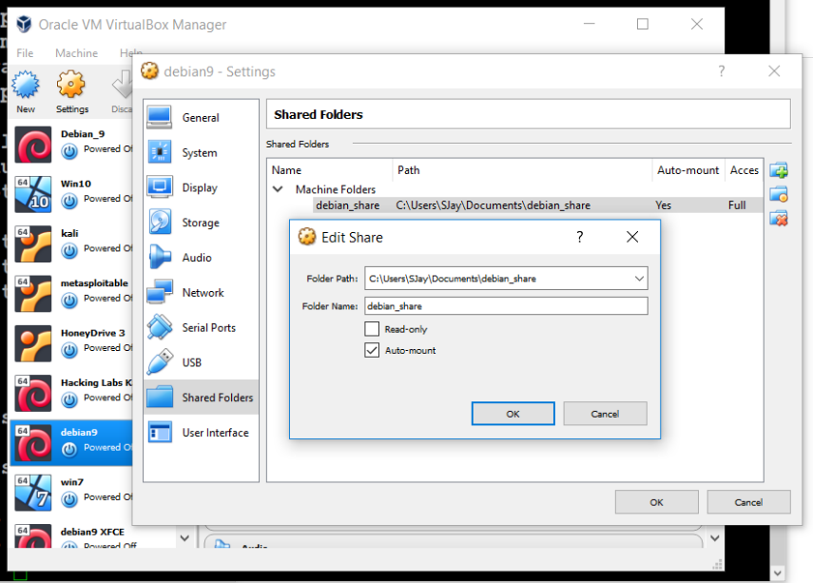

Start up your VM again, and you can now add this shared folder as a mount to an empty directory somewhere on your system. If you want to do this as root, become root, and create a directory with the following:

mkdir ~/vbox_share

Now you can mount the folder share with the mount command and a special file system created when you installed the vbox guest software above with:

mount -t vboxsf debian_share ~/vbox_share/

You can now copy files into your windows share and it will appear in your Debian directory!

### Windows

Process is the same as above, however, you don’t need to pre-install the missing modules. When you add your addons disk to your Windows VM, it may auto launch or you can launch it, but all the software will be installed. At that point, you can then mount the share as a network share in VirtualBox.

First you will need to setup Guest Additions.

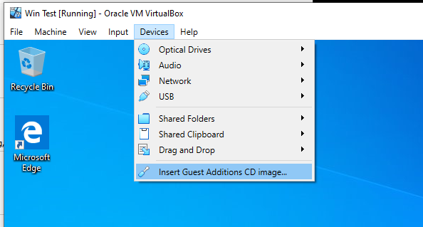

When added, you should get a notification in the system tray of the VM that the CD is installed. Navigate in Explorer to the CD, and launch the installer.

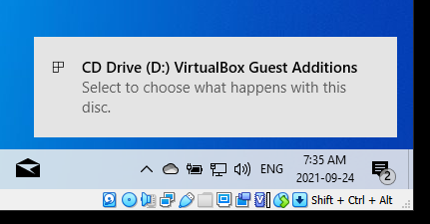

The installer is pretty straight forward. You will need to allow the software to make changes to your VM, as seen here:

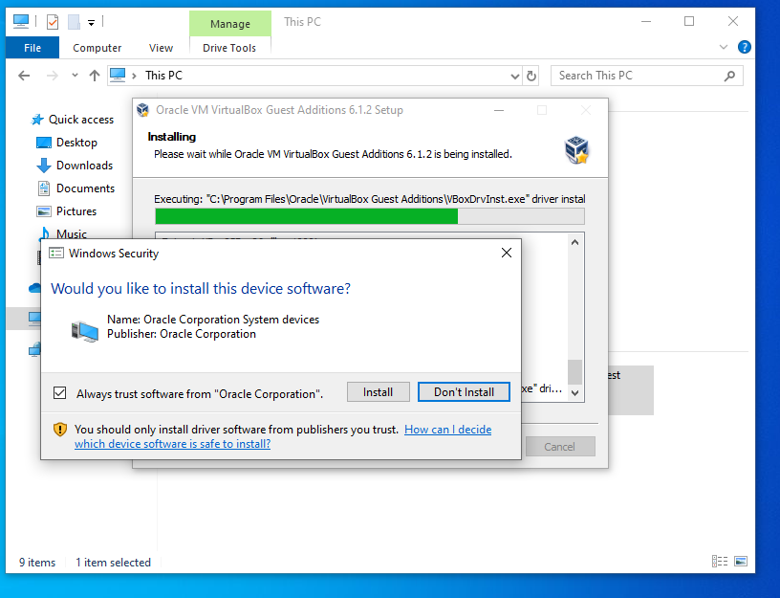

Once the install is complete you will need to reboot your VM:

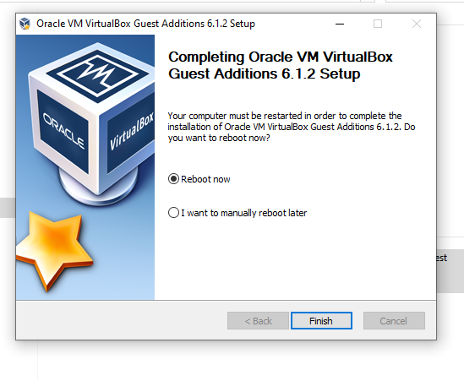

Power off the VM after the reboot, and as with Debian, create a new share for your VM:

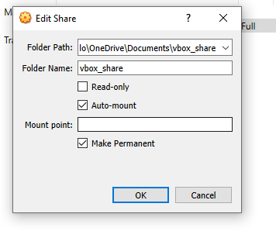

You can then find the share in your network on your VM. You will likely need to turn on network services and discovery in your Windows, but when you do, it should look something like this:

